Anthony Bugatto

EE 436: Microwave Engineering

Sonnet LPF Design

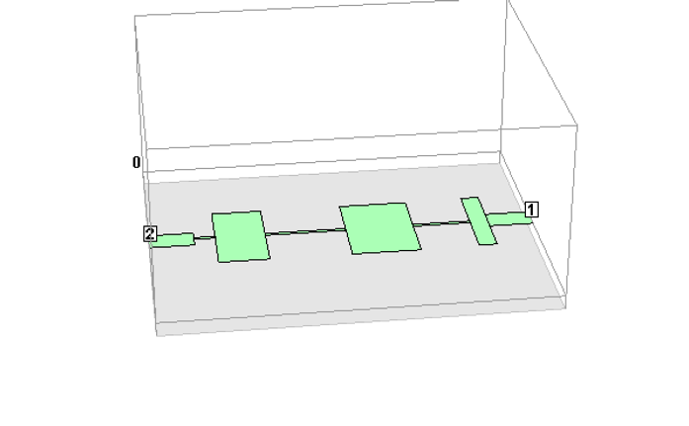

Figure 1: 3D Model of Filter

This project we designed a stepped impedance low-pass filter with a maximally flat response and cutoff frequency of 2.5GHz. In order to do this, we followed the design process and data found in example 8.6 in the book. Figure 1 shows the 3D design of the filter, which follows the parameters in the book. We used copper according to the parameters as well as a dielectric according to the parameters. Figure 2 shows the implementation on the sonnet editor with the the three high impedance capacitors, two low impedance inductors, and matched 50Ohm lines at the ends with ports. The response looks fairly similar to the desired response and seems to have a cutoff right around 2.15, which is close to the 2.5GHz we designed for. In figure 3 we can see the simulated response and in figure 4 we can see the simulated response in the book. As the book’s response is correct, we can see that the simulated response of S21 approximates the book S21 very accurately and if you look at the S11 response it clearly starts out with a low reflectance coefficient but becomes almost entirely reflecting as the filter starts to deny low high frequencies. Figure 5 shows some sample current data from different frequencies between .1GHZ-5GHz. Following the current response, it can be seen that in the beginning and the middle there is very low reflectance throughout the circuit and most of the input makes it out of the filter. In the last current response frequency, we can see that the majority of the current reflects back into port 1, as it should for high frequencies. In conclusion this project taught me a lot about how these kinds of filters work and that I need to double check my implementation at each step of the way.

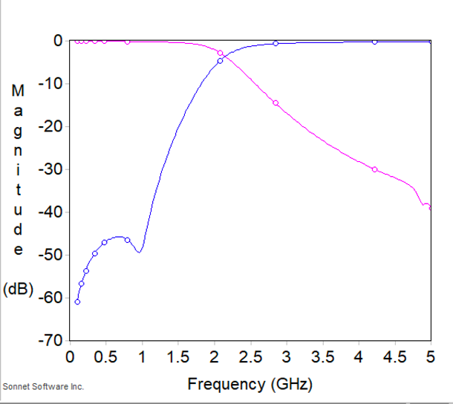

Figure 3: Frequency Response of S11(blue) and S21(red)

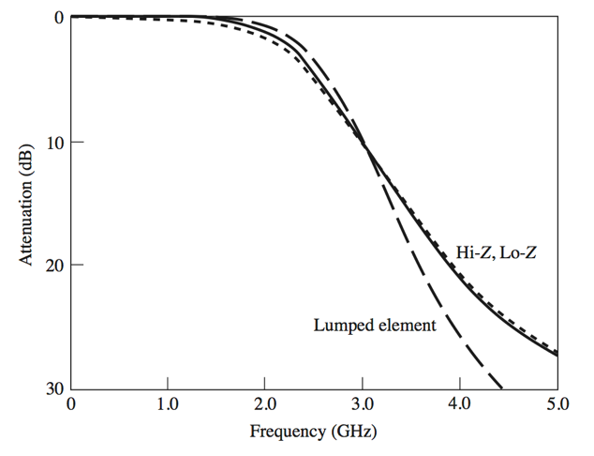

Figure 4: Book S21

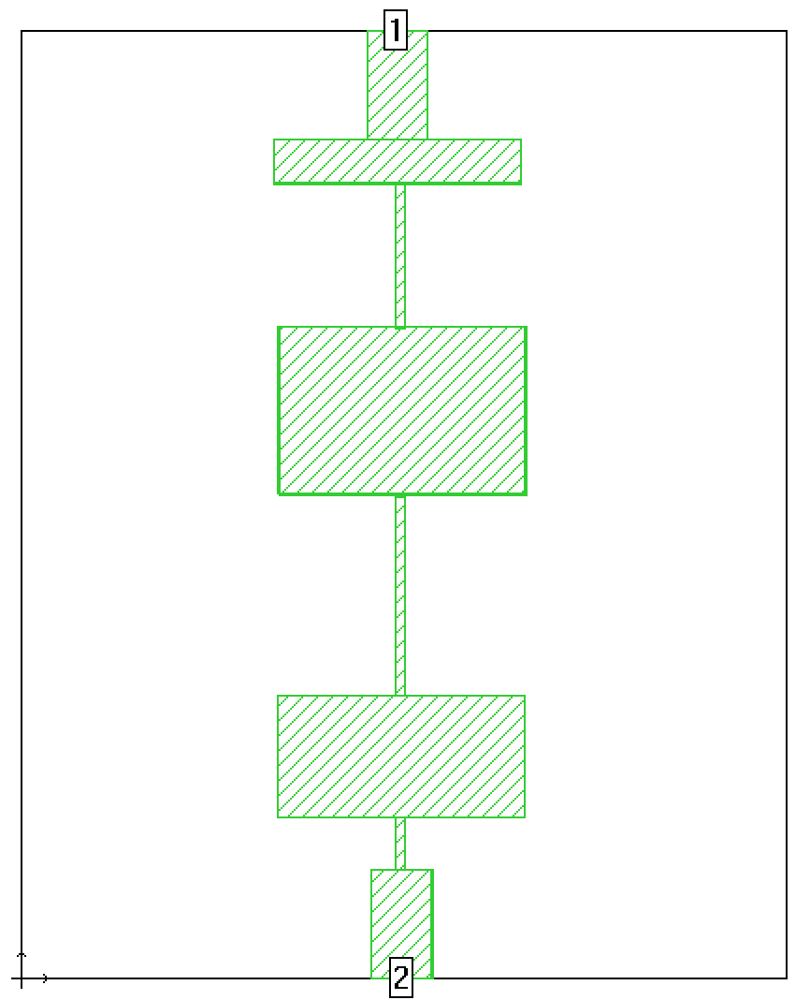

Figure 2: Model of Filter

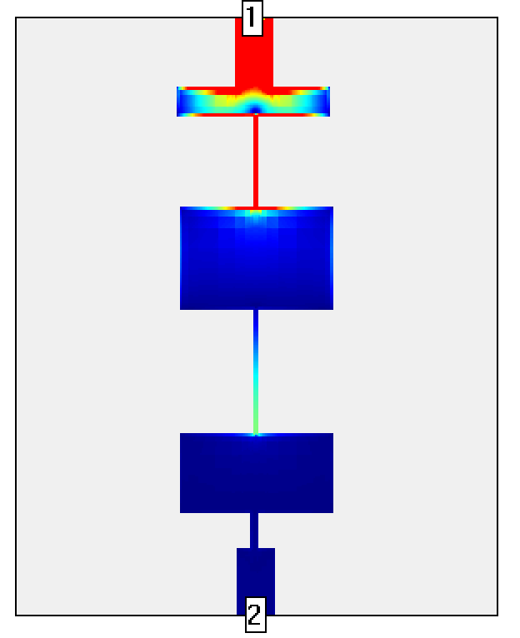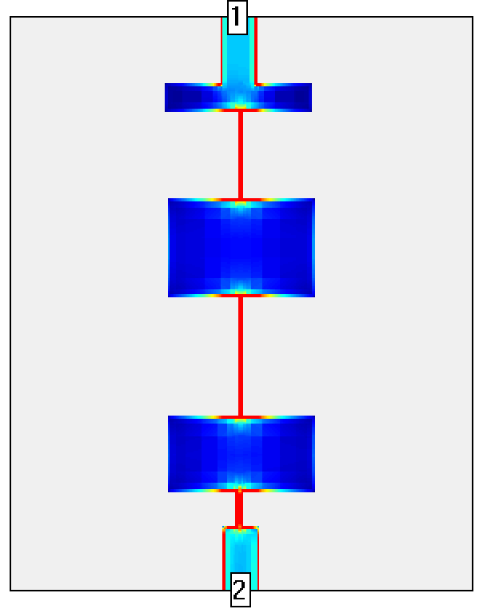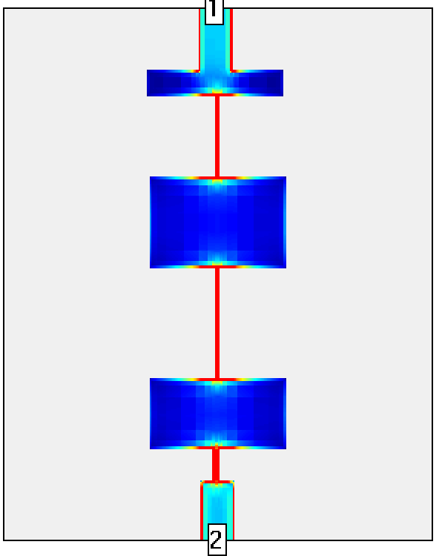

Figure 5: Current Response at beginning, middle, and end of frequency range